**Windows 8 USB Installer Maker**

**Windows 8 USB Installer Maker** is a utility written for Windows 7 (not tested on other Windows versions), it will help you build a Windows 8 installer using your USB pendrive and the DVD ISO image.

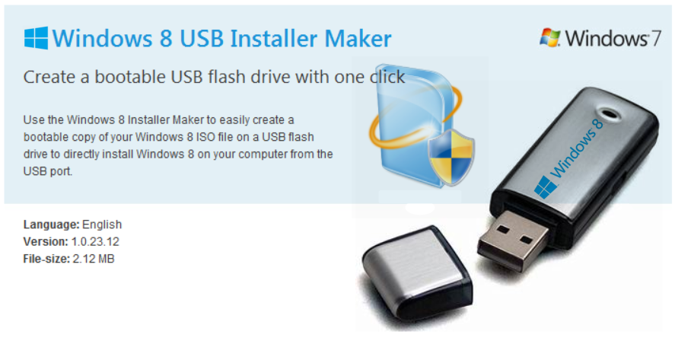

This tool allows you to create a copy of your Windows8 ISO file on a USB flash drive. Just download the ISO file and then run the Windows 8 USB Installer Maker tool. After you do this, you can install Windows 8 directly from the USB flash drive.

**Requirements:**

* Windows 7 x86/x64
* USB Pendrive at least a 4GB
* Windows 8 DVD ISO image

**Author:**

Victor Alberto Gil <vhanla>

Website: **http://apps.codigobit.info**

**DISCLAIMER:**

USE IT AT YOUR OWN RISK, ANY DAMAGE TO YOUR COMPUTER, YOUR WIFE, YOUR PETS IS NOT THE AUTHOR'S RESPONSIBILITY.

WINDOWS 8 IS A TRADEMARK REGISTERED TO MICROSOFT CORPORATION.

**How to use:**

1. Connect your USB flash drive and make sure it is recognized correctly by your Windows machine
2. Start **Win8USB.exe** ( you need administrative privileges since it needs elevated access to your usb drive )

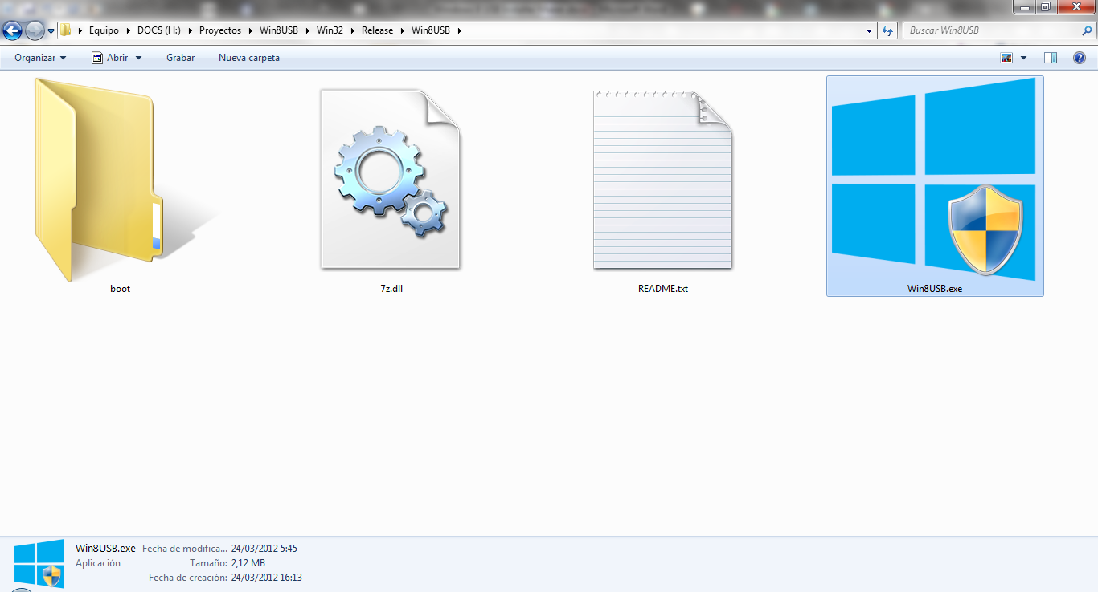

1. Select your USB drive and **make sure it has a NTFS filesystem format** and at least 4GB of capacity

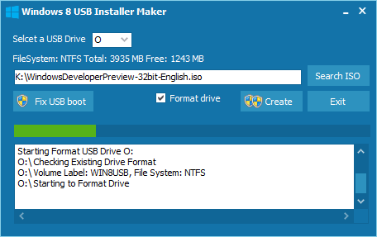

1. Search for the ISO file

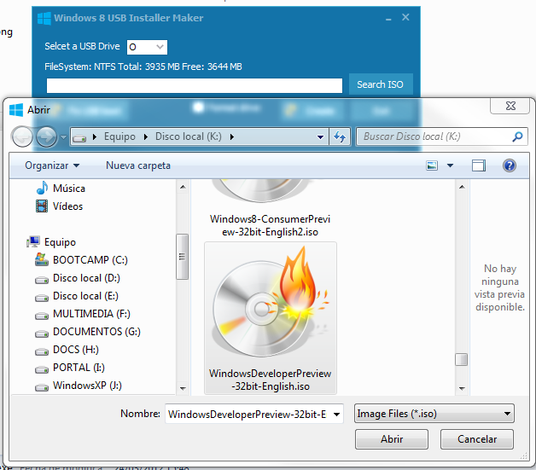

1. Once located the ISO image file, check **Format drive** (this is mandatory if you have free space less than required and also if you don’t have a NTFS formatted USB drive, maybe is FAT32, so check this, this is recommended, and don’t forget that it will destroy any file found in that USB drive)

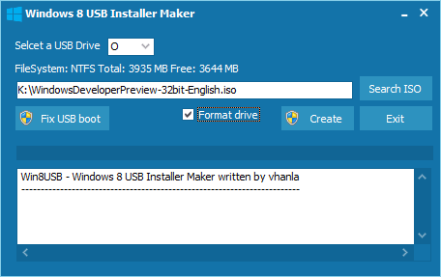

1. Finally click **Create** button and wait patiently, very patiently

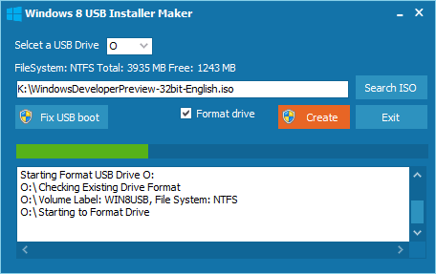  
At this point the tool is formatting your pendrive

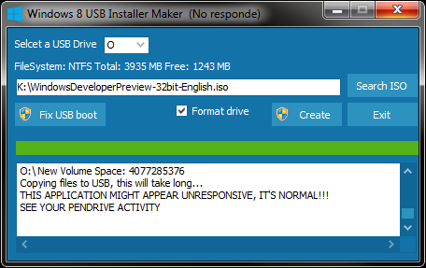

Now it started unpacking all the installation files to your USB drive and according to your USB drive speed it will take its time, **notice that it shows the utility as hung and unresponsive, it is normal**, just make sure that your pendrive is in activity, because all files should be copying in background.

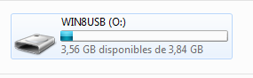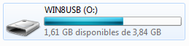

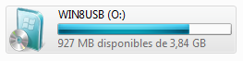

See that your USB drive is being filled

1. Finally you will see in the log text that it has written the boot entry to you USB (now your USB drive is bootable)

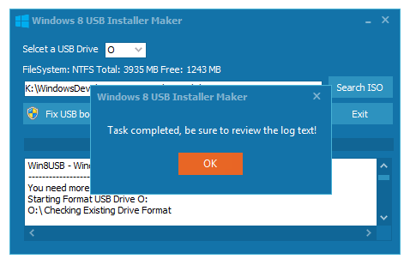

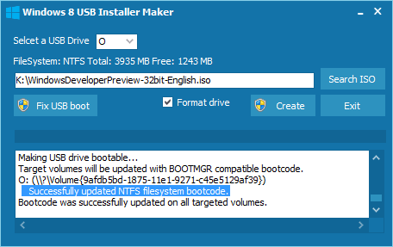  
Make sure it says “***Successfully updated NTFS filesystem bootcode.***” Otherwise click the **Fix USB boot** button

1. Now it only lefts to reboot your PC, modify your BIOS boot device (choose your USB drive making sure it has been plugged in before entering the BIOS).

*“If you like my work, maybe you would want to donate, I’d appreciate it.”* <http://apps.codigobit.info/p/support.html>